Robot Hand Overview

Version 1.0

Date: 12/17/20

Author: Nikolai Tiong

This is an overview of the Robot Hand project and all the documents and files within. Arduino sketches and python scripts are commented with details about the function of them.

# Fusion 360 Files

FANUC EOAT Adapter v14 – the mount for the hand, created by Zane in previous semester’s project.

PowerBoxV15 – The case for the power delivery to the end of the FANUC robot arm

Standard_keystone_bracket_for_3D_projects – This was obtained from Googling keystone jack models. It is used in PowerBoxV15.

# Python Scripts

Robot_hand_command.py – the ROS script to send movement commands to the hand

Robot_hand_position.py – the ROS script to receive the current position of the individual fingers of the hand

# Arduino Sketches

Robot-hand-ros – controls the finger movements of the robot hand. Is running on an Adafruit Feather M0 with an Ethernet Featherwing on top of it. I have tested this on an ESP32 Feather and it gets stuck in a boot loop due to the Ethernet shield.

Servo_calibrate – The program to run on the robot hand when calibrating the servos. It loops through opening and closing the hand and prints the analogRead() to serial console. This can be copy and pasted into a text file, saved as a .csv and imported into a spreadsheet. From there, it can be pasted into the relevant cells on the calibration_example.xlsx spreadsheet and the values for the multiplier and shift will be updated on the graphs straight away.

Servo_readings – This opens and closes the hand and prints out the finger positions after using analogRead() and applying the multipler and shift. This can be copy, pasted and imported into a spreadsheet and then pasted into calibrated_servo_example.xlsx to see how well the calibration worked.

# Spreadsheets

calibration_example – contains the results of a calibration with graphs for each finger showing the multiplier and shift to use in the Arduino sketches.

calibrated_servo_example – contains the calibrated readings of each finger and shown on a graph.

# Powerpoint

CS 553 Project Presentation – my presentation at the end of Fall 2020 on the entire project.

# Word

FANUC Robot Arm Power Box – and overview of the power box and the hardware used in case replacements are needed.

# The Robot Hand

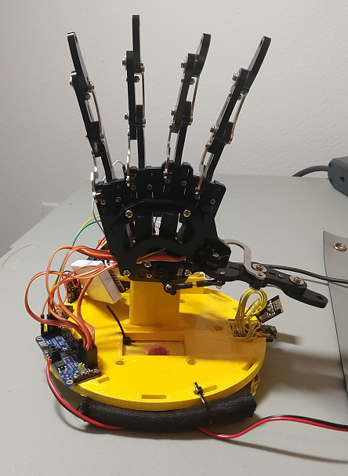

Figure : The robot hand.

Figure : Block diagram of the entire system architecture

# Hardware Used:

Analog Feedback Micro Servo - Metal Gear x 10 $14.95 each

5 are used on the hand currently, with 5 spares as of 12/17/20

<https://www.adafruit.com/product/1450>

Analog Feedback Micro Servo - Plastic Gear x 5 $9.95 each

These were the first ones purchased. I killed some of them when trying to incorporate them into the sketch. Their movements were reversed compared to the original servos – TS90D – blue ones that come with Arduino kits.

<https://www.adafruit.com/product/1449>

Adafruit 16-Channel 12-bit PWM/Servo Driver - I2C interface - PCA9685 $14.95

The servo controller, was already installed when given to me. This requires external power separate from the Arduino on the V+ pin, or screw terminals. The current draw on this when all 5 fingers are moving can exceed 1A – well above what an Arduino can provide. This should be connected to the 5V buck converter’s screw terminals.

<https://www.adafruit.com/product/815>

2x Adafruit Feather M0 $20

The Arduino used to run robot-hand-ros. The Adafruit Feather LoRa M0 also works, the LoRa module must be disabled in order for the Ethernet module to work - pinMode(8, INPUT_PULLUP);. This is in the sketch.

<https://www.adafruit.com/product/2772>

1x Ethernet Featherwing $25

Provides non-PoE networking to the Feather M0. Needs an Adafruit library to run.

<https://www.amazon.com/Adafruit-PID-3201-Ethernet-FeatherWing/dp/B01LHSUR6U/ref=sr_1_15?dchild=1&keywords=adafruit+featherwing&qid=1600406542&sr=8-15>